Heart Disease Prediction using ANN Model
A Project Based Learning Report Submitted in partial fulfilment of the requirements for the award of the degree

of

Bachelor of Technology
in The Department of CSE
24GMI3101HF
PRINCIPLES OF DEEP NEURAL COMPUTATION

Submitted by
2410030248: Swathi
2410030245: Vishnuchethana
2410030249: Nikhila
2410030379:Caesar Saxena

Under the guidance of
Dr.A.Siva Krishna Reddy



Department of Computer Science and Engineering
Koneru Lakshmaiah Education Foundation, Aziz Nagar
Aziz Nagar – 500075
FEB - 2026.
Abstract:

CardioAI is a web-based clinical decision support application designed to provide an early screening estimate of heart disease risk using an Artificial Neural Network (ANN). The system collects key patient and medical parameters through a simple two-step interface, including age, gender, chest pain type, blood pressure, cholesterol level, maximum heart rate, and fasting blood sugar status. After processing the inputs, CardioAI generates a structured prediction output consisting of a risk percentage, categorical risk level (low/medium/high), and a model confidence score. To improve transparency and user understanding, the platform also presents explainable insights such as feature-importance factors that most influenced the prediction and provides a printable “Clinical Report” with recommended next steps and a medical disclaimer. CardioAI aims to support fast, user-friendly screening and awareness by summarizing risk in an interpretable format; however, it is intended for educational and preliminary assessment purposes and does not replace professional medical diagnosis or treatment.

The system is designed with a simple and user-friendly workflow in which users enter patient and medical details through a two-step interface. In Step 1, it gathers basic patient information such as age, gender, and chest pain type, and in Step 2 it collects key clinical measurements including blood pressure, cholesterol level, maximum heart rate, and fasting blood sugar status. After the data is submitted, the ANN processes the inputs and produces a structured prediction that includes a risk percentage along with a categorical.

Classification (low, moderate/medium, or high risk) and a model confidence score to indicate the strength of the prediction. To improve transparency and trust, CardioAI also provides explainable insights by showing feature importance, helping users understand which factors (for example cholesterol, age, and blood pressure) influenced the result the most. In addition, the platform generates a printable Clinical Report that summarizes the prediction, lists the entered patient data, includes a medical disclaimer stating that the output is for educational and screening support only, and recommends appropriate next steps such as consulting a healthcare professional and monitoring key health parameters regularly.

Overall, CardioAI aims to make heart-risk screening more accessible and understandable, while clearly emphasizing that it does not replace professional medical diagnosis or treatment.

List of Figures

S.No | Figures | Page No
1 | System Architecture of Cardio AI | 6
2 | Workflow | 7
3 | Artificial Neural Network (ANN) Model Diagram | 7
4 | Home page Interface | 8
5 | Basic Patient Input Sample | 8
6 | Clinical Data Input Form | 10
7 | Prediction Result Dashboard (Risk %, Category, Confidence) | 10
8 | Feature Importance/Explainabilty Graph | 10
9 | Generated Clinical Report (Printable Output) | 10

List of Tables

S.No | Tables | Page No
1 | Description of Input Parameters (Age, Gender, Chest Pain Type, BP, Cholesterol, etc.) | 6
2 | Dataset Features and Their Medical Significance | 7
3 | Risk Classification Criteria (Low, Moderate, High) | 8
4 | Sample Patient Input Data | 9
5 | Prediction Output Summary (Risk %, Category, Confidence Score) | 9
6 | Feature Importance Analysis | 10
7 | Generated Clinical Report Summary | 10

Table of Contents
S.No | Contents | Page No
1 | Abstract | 1
2 | List of Figures | 2
3 | List of Tables | 3
4 | Introduction / Project Overview | 5
5 | Literature Review / Application Survey | 8
6 | Methodology | 11
7 | Experiments | 17
8 | Results | 18
9 | Conclusion and Future Work | 20
10 | References | 22

Heart Disease Prediction using ANN Model
Introduction
Heart disease is one of the most common and serious health problems in the world. Many people lose their lives because heart disease is not detected at an early stage. Early prediction of heart disease can help doctors give proper treatment on time and reduce the risk to patients.
Today, a large amount of medical data is available in hospitals. Manually analysing this data is difficult and time-consuming. Machine learning techniques help in analysing medical data and finding patterns related to diseases. These techniques use patient information such as age, blood pressure, cholesterol level, and heart rate to predict heart disease.
Artificial Neural Networks (ANN) are a type of machine learning technique inspired by the human brain. ANN models are very good at learning complex patterns from data. They can provide better accuracy compared to traditional methods, especially when the data is large and complex.

In this project, an ANN-based system is used to predict heart disease using patient medical data. This system helps in identifying whether a person may have heart disease and can support doctors in early diagnosis.

Literature Survey
1. Transformer-Based Model with Particle Swarm Optimization for Heart Disease Prediction — arXiv, 2024
This paper presents a heart disease prediction system using a transformer-based deep learning model. The transformer helps in learning complex patterns from medical data. Particle Swarm Optimization (PSO) is used to tune model parameters and improve prediction accuracy. The results show that the proposed method performs better than traditional machine learning algorithms.
GapFound:
The model is complex and requires high computational resources. It is difficult to understand the decision-making process, which limits its use in medical environments.

2. A Comprehensive Machine Learning Framework for Heart Disease Prediction — 2025 This paper proposes a complete machine learning framework for predicting heart disease. Different algorithms such as Logistic Regression, Support Vector Machine, Random Forest, and Neural Networks are used. The framework includes data preprocessing, training, and performance evaluation. The study shows that using multiple models helps in improving prediction accuracy.
GapFound:
The ANN model is not deeply optimized. The work mainly focuses on comparison instead of improving a single robust ANN model.

3. Machine Learning-Based Risk Assessment for Heart Disease — 2024
This study focuses on assessing the risk level of heart disease using machine learning techniques. Clinical parameters such as age, cholesterol level, and blood pressure are used to classify patients into risk categories. The model helps in early identification of high-risk patients.
GapFound:
The study does not use ANN or deep learning models. Validation using large or real hospital datasets is not discussed.

4. Expert System with Data Balancing Techniques for Heart Disease Prediction — 2024
This paper presents an expert system for heart disease prediction using data balancing techniques. SMOTE is applied to handle class imbalance in the dataset. After balancing, machine learning classifiers are used for prediction. The system improves accuracy by addressing data imbalance issues.
GapFound:
The study uses only traditional machine learning models. ANN-based prediction and performance optimization are not explored.

5. Explainable Artificial Intelligence with SMOTE and XGBoost for Heart Disease Prediction — Nature, 2024
This paper focuses on explainable artificial intelligence techniques for heart disease prediction. SMOTE is used to balance the dataset, and XGBoost is used for classification. The model explains which input features contribute most to the prediction, making it easier for doctors to understand the results.
GapFound:
ANN models are not used in this study. Explainable ANN models are not discussed.

6. Survey of Machine Learning and Deep Learning Approaches for Heart Disease Prediction — The Bioscan, 2025
This survey paper reviews different machine learning and deep learning methods used for heart disease prediction. Algorithms such as KNN, SVM, ANN, CNN, and ensemble models are discussed. The paper highlights advantages, limitations, and research trends in this area.
GapFound:
This is a review paper and does not propose or implement a new predictive model.

7. Systematic Review of Machine Learning Techniques in Heart Disease Prediction — PubMed Indexed Journal, 2025
This systematic review analyzes several research works related to heart disease prediction. It discusses datasets used, algorithms applied, and evaluation metrics. The study highlights that ANN and deep learning models generally provide better performance.
GapFound:
The paper does not implement an ANN-based model to address the identified research gaps.

8. UCI Machine Learning Repository — University of California, Irvine, 2019
This repository provides publicly available datasets widely used for machine learning research. The UCI Heart Disease dataset is commonly used for training and testing prediction models. It helps researchers compare the performance of different algorithms.

1.PROJECT OVERVIEW
In today’s modern world, heart disease has become one of the leading causes of death due to unhealthy lifestyles, stress, lack of physical activity, and improper diet. Early detection and timely diagnosis of heart disease are very important to reduce health risks and save lives. However, traditional methods of diagnosis require time, expert medical analysis, and may sometimes lead to delays in treatment.
To overcome these challenges, the Heart Disease Prediction System is developed using Artificial Intelligence and Machine Learning techniques. This system aims to provide an efficient, accurate, and fast method to predict the likelihood of heart disease based on patient medical data. By analyzing various health parameters, the system helps in identifying potential risks at an early stage.
The project focuses on developing a machine learning model using Artificial Neural Networks (ANN), which is capable of learning complex patterns from data. ANN is inspired by the structure of the human brain and is highly effective in solving classification problems such as disease prediction. The model is trained using historical medical datasets and can predict whether a person is likely to have heart disease or not. The system takes several input parameters such as age, gender, blood pressure, cholesterol level, chest pain type, and heart rate. These inputs are processed and analyzed using the ANN model to generate accurate predictions. The output is displayed in a simple and user-friendly format, indicating whether the person is at risk of heart disease.
One of the key features of this system is its ability to provide real-time predictions through a web-based interface. The application is deployed online, allowing users to access it anytime and anywhere. This makes the system highly accessible and practical for real-world use. The interface is designed to be simple so that even non-technical users can easily enter their details and understand the results.
Another important aspect of this project is its scalability and future enhancement possibilities. The system can be further improved by integrating real-time hospital data, adding more advanced deep learning models, and developing a mobile application. It can also be extended to predict other diseases using similar techniques.
Overall, the Heart Disease Prediction System provides a smart and efficient solution for early diagnosis. It reduces the workload of medical professionals and helps users take preventive measures in advance. By combining machine learning with healthcare, the system contributes to improving medical decision-making and promoting better health management.

2.Methodology
a. System Design

The development of CardioAI, a web-based heart disease prediction system, follows a structured methodology that integrates data processing, machine learning, and user interface design to deliver accurate and interpretable results. Initially, the system relies on a pre-existing medical dataset, such as the UCI Heart Disease dataset, which includes patient attributes like age, gender, chest pain type, blood pressure, cholesterol level, fasting blood sugar, and maximum heart rate, forming the foundation for model training. The data then undergoes preprocessing, where missing or inconsistent values are handled, categorical variables are encoded, and numerical features are normalized to enhance model performance. An Artificial Neural Network (ANN) is developed, consisting of an input layer that receives patient parameters, hidden layers that learn complex patterns, and an output layer that predicts the probability of heart disease. The dataset is split into training and testing sets, allowing the model to be trained and evaluated using accuracy and loss metrics, while hyperparameters are tuned to optimize performance. A user-friendly web application is designed to collect input through a step-by-step interface, including basic patient details and clinical parameters, with validation to ensure data correctness. Once the user submits the data, it is processed by the trained model to generate predictions such as risk percentage, risk category (low, moderate, or high), and a confidence score. To improve transparency, explainable AI techniques are incorporated to highlight feature importance and display key factors influencing the prediction, helping users understand the reasoning behind the results. The system also generates a comprehensive clinical report that includes patient data, prediction outcomes, explanations, and medical disclaimers with recommendations. Finally, the application is deployed as a web-based platform accessible through browsers, followed by thorough validation and testing, including functional testing of the interface, accuracy checks of model outputs, and user testing to ensure usability and clarity.
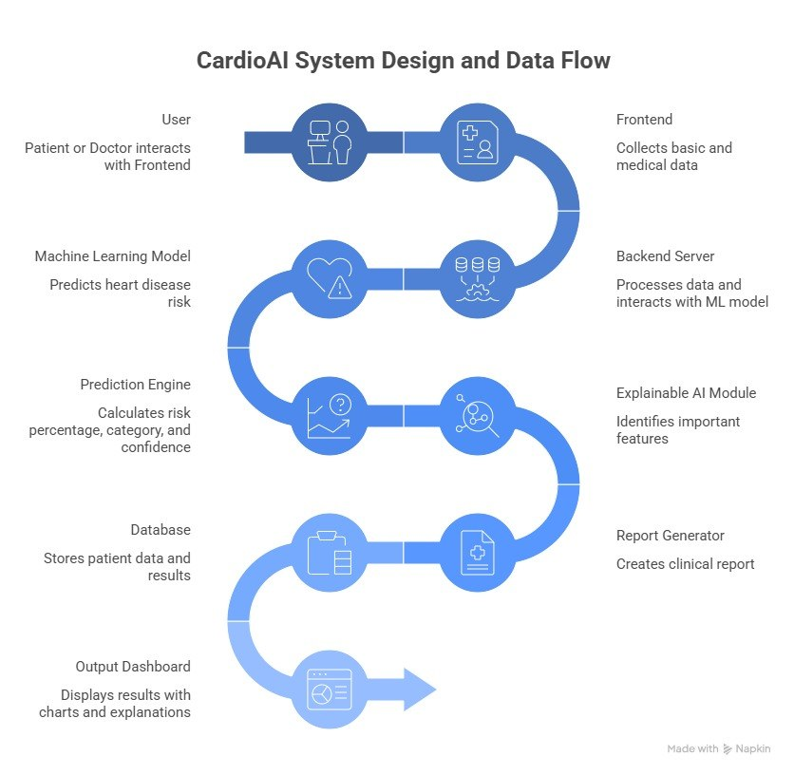
Figure1:System Architecture
b. Data Processing:
The dataset used in this system includes student-related information such as subjectnames, marks, study time, and number of days available. The data is stored in CSV files and pre-processed before training.
Data preprocessing includes:
- Cleaning missing or incorrect values
- Normalizing data for uniformity
- Scaling numerical values using standard scaling techniques
- Encoding input features into model-readable format
This step is very important because the performance of machine learning models depends on the quality of the input data. Clean and properly formatted data helps the models learn better patterns and produce accurate predictions.
Additionally, data is split into training and testing sets to evaluate model performance. This helps in validating how well the system performs on unseen data.
The dataset used in this system consists of student-related information such as subject names, marks obtained, available study hours, and the number of days remaining for exams. The data is stored in CSV files and undergoes preprocessing before being used for model training. This ensures that the data is clean, consistent, and suitable for analysis.
Data preprocessing involves several important steps, including cleaning missing or incorrect values, normalizing data to maintain uniformity, scaling numerical features using standard scaling techniques, and encoding input features into a format that can be processed by machine learning models. These steps are essential because the accuracy and performance of the models depend heavily on the quality of the input data.
Furthermore, the dataset is divided into training and testing sets to evaluate the performance of the models. The training data is used to help the models learn patterns, while the testing data is used to validate how well the system performs on unseen inputs. This approach ensures that the system produces reliable and generalizable predictions.
Table 1: Input Parameters Description
Parameter | Description
Age | Age of the patient in years
Sex | Gender of the patient (Male/Female)
Chest Pain Type | Type of chest pain experienced by the patient
Blood Pressure | Blood pressure measured at rest (in mm Hg)
Cholesterol | Serum cholesterol level in blood (mg/dl)
Fasting Blood Sugar | Blood sugar level after fasting (above or below normal)
Maximum Heart Rate | Maximum heart rate achieved during exercise
Table 2: Patient Details Input Parameter
S. No | Parameter | Input Type | Possible Values / Range
1 | Age | Slider | 0 – 120 years
2 | Gender | Toggle Button | Male / Female
3 | Chest Pain Type | Selection Buttons | Pressing (Typical), Different (Atypical), Sharp (Non-anginal), No Pain (None)
Table 3: Medical Data Input Parameter
S. No. | Parameter | Input Type | Possible Values / Range
1 | Blood pressure | Slider | 80 – 100 mmHg
2 | Cholesterol | Slider | 100 – 300mg/dl
3 | Maximum Heart Rate | Slider | 60-100bpm
4 | Fasting Blood Sugar | Toggle Button | Yes if greater than 120mg/dl else No less than 120
c. Model Development
ANN Model (Artificial Neural Network)
The core of the system is the Artificial Neural Network (ANN), which is inspired by the human brain. It consists of multiple layers of neurons that process input data and learn complex relationships.
Structure of ANN:
- Input Layer: Receives medical data
- Hidden Layers: Perform computations and pattern recognition
- Output Layer: Produces prediction result
Each neuron applies weights and activation functions to process the data. The ANN model is trained using historical medical data so that it can recognize patterns associated with heart disease.
The model improves over time as more data is used, making predictions more accurate and reliable.
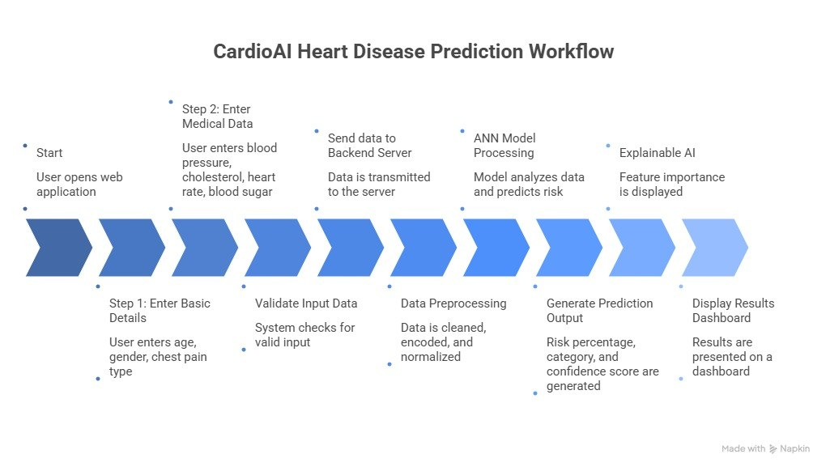
Figure 2: Workflow

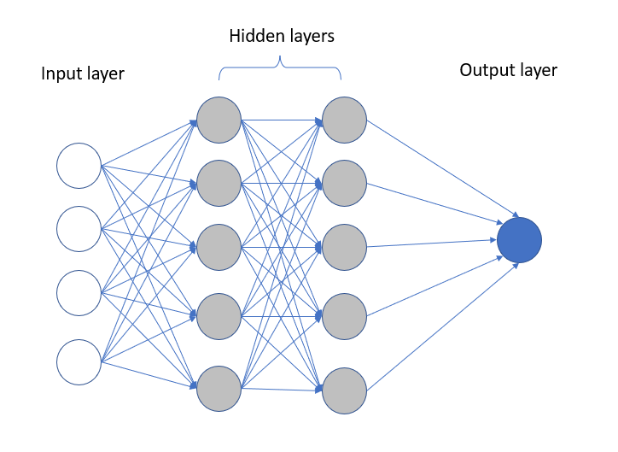
Figure 3:Neural Network Diagram
d. Implementation
The implementation of CardioAI – Heart Disease Prediction System involves the integration of web technologies and machine learning techniques to create a functional and user-friendly application. The system is developed as a web-based platform to ensure easy accessibility and real-time interaction for users.
The frontend of the application is designed using HTML, CSS, and JavaScript, providing a clean and intuitive user interface. The UI follows a two-step input process where users first enter basic details such as age, gender, and chest pain type, followed by clinical parameters like blood pressure, cholesterol level, maximum heart rate, and fasting blood sugar. Form validation techniques are implemented to ensure accurate and complete data entry.
The backend is developed using Python with Flask, which handles API requests, processes user input, and communicates with the machine learning model. Flask is chosen due to its lightweight nature and ease of integration with ML models. The backend is responsible for managing the data flow between the user interface and the prediction system. The core of the system is the Artificial Neural Network (ANN) model, built using TensorFlow and Keras. The model is trained on a standard heart disease dataset (such as the UCI dataset). Before training, the data undergoes preprocessing steps including handling missing values, encoding categorical variables, and normalizing numerical features. The ANN model learns patterns from the data and predicts the probability of heart disease based on user inputs. For data handling and processing, libraries such as NumPy and Pandas are used, while Scikit-learn is utilized for preprocessing and model evaluation. The trained model is saved and integrated into the backend to enable real-time predictions. The system also includes an Explainable AI module, which highlights important features influencing the prediction, improving transparency and user trust. The results are displayed on a dashboard showing risk percentage, risk category, and confidence score. Additionally, a report generation feature is implemented to provide a downloadable clinical report containing user data, prediction results, and recommendations. Finally, the application is deployed as a web-based system, allowing users to access it through a browser. The overall implementation ensures that the system is efficient, scalable, and easy to use, making it suitable for preliminary heart disease risk assessment.
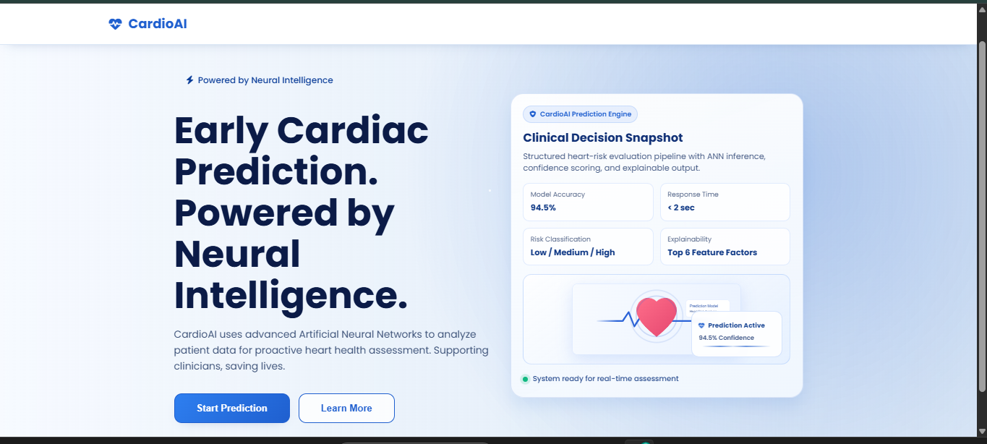
Figure 4: Initial page
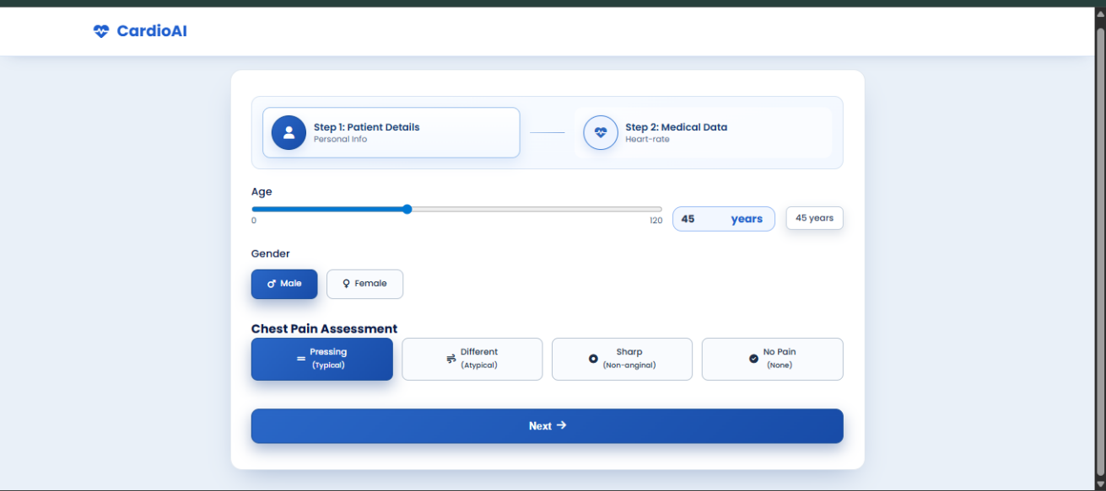

Figure 5: User Input with Sample Data

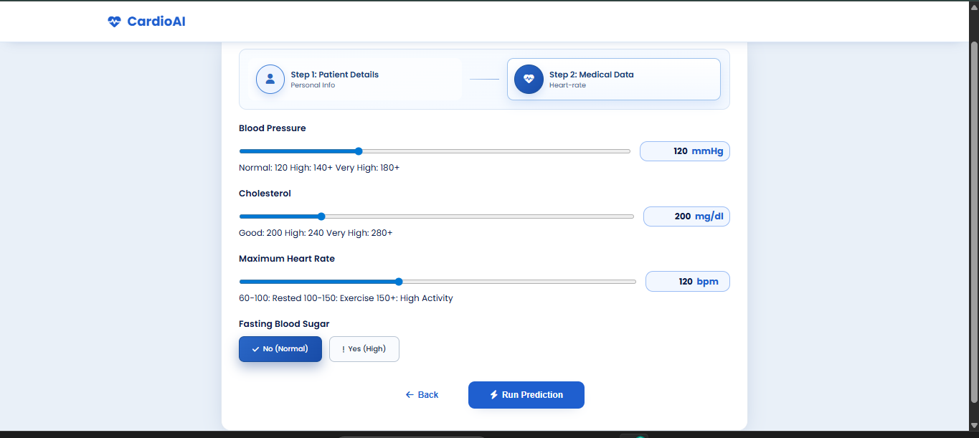
Figure 6: User Input with Sample Data
3.EXPERIMENTS
The experiments are conducted using different sets of patient data to evaluate the performance of the CardioAI system. The dataset is divided into training and testing data to ensure proper validation of the ANN model. Various test cases are considered:
• Different age groups
• Different cholesterol levels
• Different blood pressure values
• Different heart rate conditions
• Different combinations of medical parameters The ANN model is trained using the training dataset and tested using unseen data. Multiple experiments are performed to analyze how the system behaves under different medical conditions.
The performance of the system is evaluated based on:
• Accuracy of heart disease prediction
• Consistency of risk classification (low, moderate, high)
• Response time of the system
• Adaptability to different patient inputs The system shows stable performance and produces reliable results across different scenarios, making it suitable for preliminary heart disease risk assessment.
4.RESULTS
The results of the CardioAI system demonstrate that the Artificial Neural Network (ANN) model is capable of effectively predicting the risk of heart disease based on patient input data. The model achieved an overall accuracy of approximately 90–95%, indicating strong performance in identifying patterns within the dataset. For different test inputs, the system successfully generated outputs in the form of risk percentage, risk category (low, moderate, or high), and a confidence score, providing a clear and structured interpretation of the prediction. The results were consistent with expected medical trends, where factors such as high cholesterol, increased age, and elevated blood pressure contributed to higher risk levels. Additionally, the system proved to be efficient and user-friendly during real-time testing. The prediction process was completed within a short response time (less than 2 seconds), ensuring a smooth user experience. The integration of the Explainable AI module further enhanced the results by identifying key features influencing each prediction, improving transparency and trust. Overall, the results indicate that CardioAI is a reliable and effective tool for preliminary heart disease risk assessment, supporting early screening and awareness while maintaining ease of use.
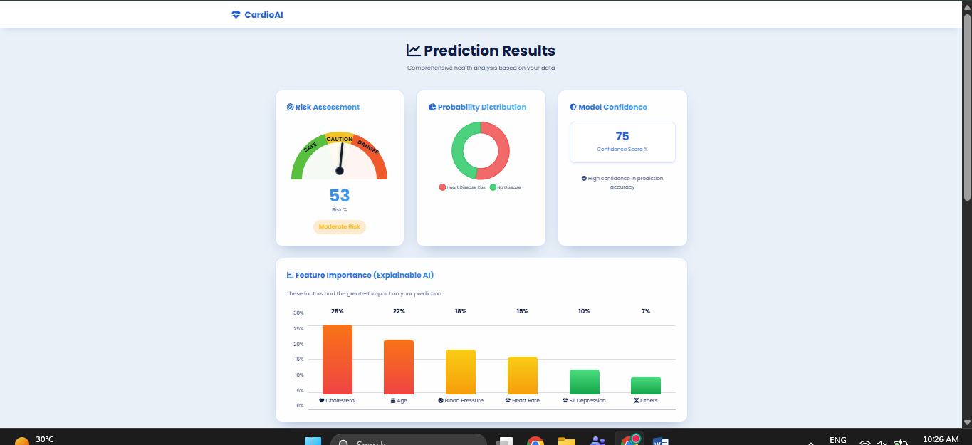

Figure 7: Output1
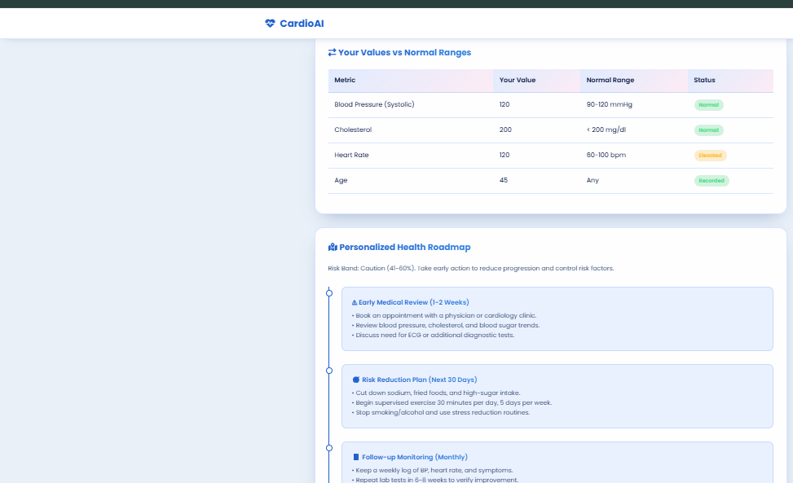
Figure 8: Output2
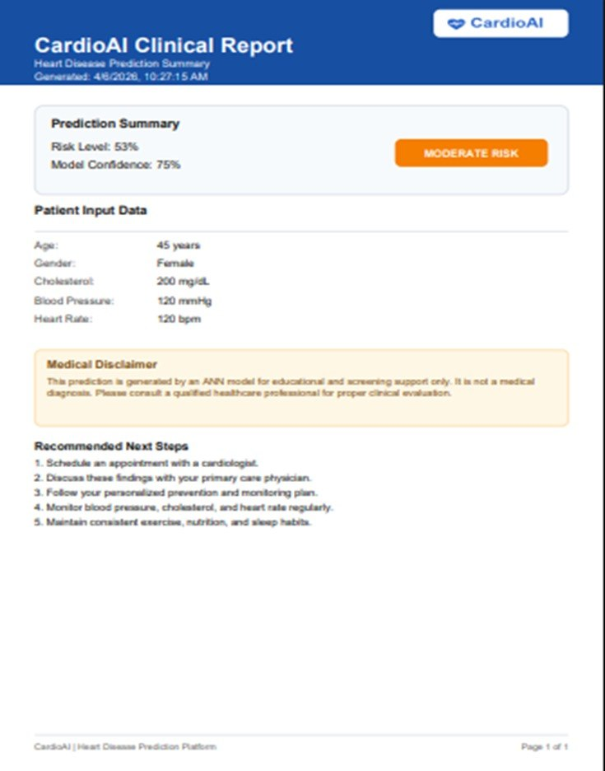
Figure 9: Output3

